Project Design Phase-II
Data Flow Diagram & User Stories

Date | 12 February 2026
Team ID | LTVIP2026TMIDS26598
Project Name | Prevent User Deletion If Assigned to Incident
Maximum Marks | 5 Marks

What is DFD?

A Data Flow Diagram (DFD) represents the movement of data within a system. In this project, it shows how user records and incident data interact within ServiceNow to ensure proper incident management. The diagram illustrates how an administrator attempts to delete a user, how the system checks whether the user is assigned to any active incidents, and how the validation mechanism (Business Rule) either blocks or allows the deletion. This ensures data integrity, maintains incident ownership, and prevents accidental disruption of IT service workflows.

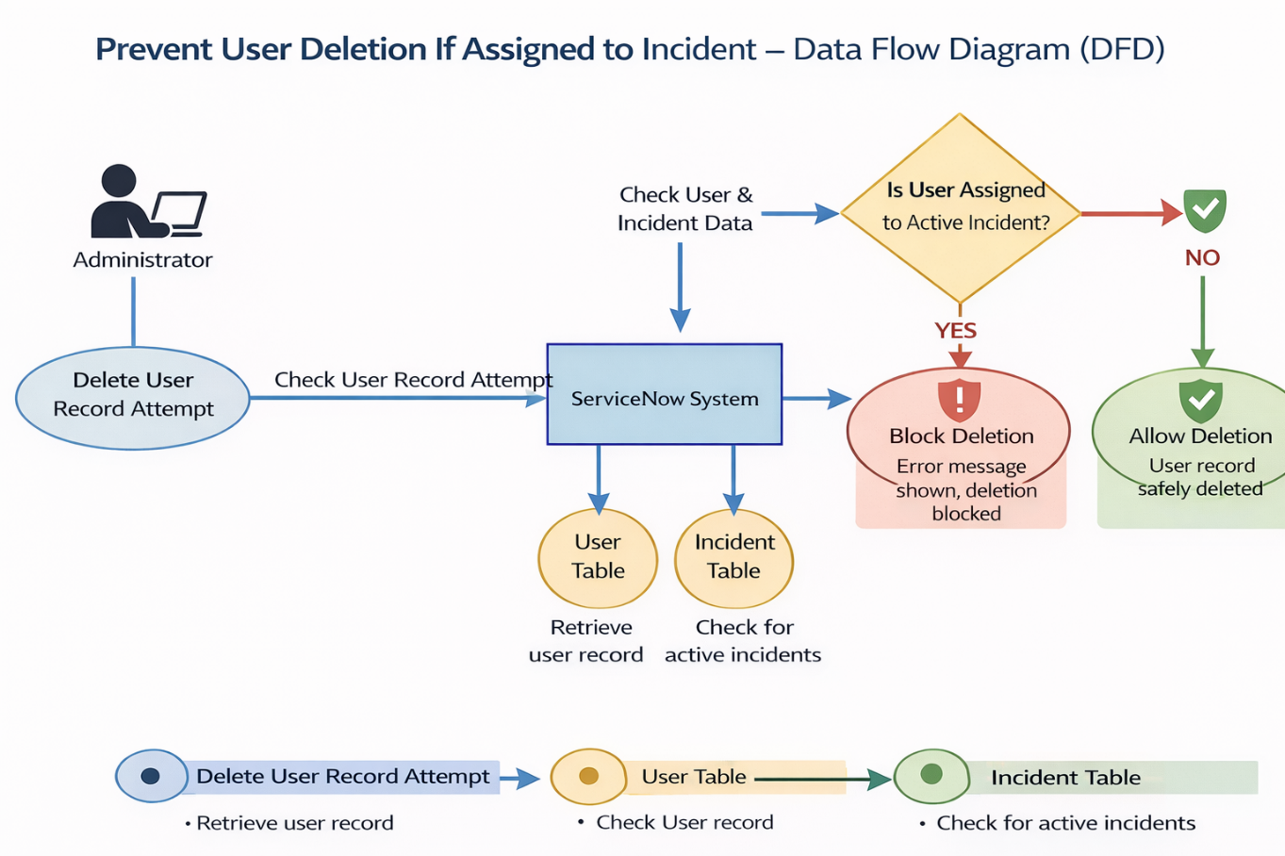

User Stories:
Below are the user stories for our ServiceNow project:
User Type | Functional Requirement (Epic) | User Story No | User Story | Acceptance Criteria | Priority | Release
ServiceNow Admin | User Management | USN-1 | As an admin, I can create a new user in the system. | User record is saved in sys_user table. | High | Sprint-1
ServiceNow Admin | Incident Management | USN-2 | As an admin, I can assign an incident to a user. | Incident record shows assigned user. | High | Sprint-1
ServiceNow Admin | Business Rule Configuration | USN-3 | As an admin, I can create a Before Delete Business Rule. | Business Rule is active and runs before delete. | High | Sprint-2
ServiceNow Admin | Validation | USN-4 | As an admin, I want the system to check if a user is assigned to any incident before deletion. | System queries incident table successfully. | High | Sprint-2
ServiceNow Admin | Data Protection | USN-5 | As an admin, I want deletion to be blocked if user is assigned to an incident. | Error message appears and deletion is prevented. | High | Sprint-2
ServiceNow Admin | Data Integrity | USN-6 | As an admin, I want unassigned users to be deleted successfully. | User is deleted if no incidents assigned. | Medium | Sprint-2
ServiceNow Admin | System Monitoring | USN-7 | As an admin, I can test deletion scenarios. | Assigned user deletion fails; unassigned user deletion succeeds. | Medium | Sprint-3
IT Manager | System Stability | USN-8 | As an IT Manager, I want to ensure workflow continuity. | No incident loses assigned user due to deletion. | High | Sprint-3

